

# **SKYLINK**

### 2800 S. Financial Court, Sanford, FL 32773, USA

### Tel 1-800-917-7198

### Website: <https://www.skylinkintl.com/>

# **QUALITY ASSURANCE MANUAL**

# **REV 011**

### 

### 

# **Table of Contents**

**Title** **Section Page Rev**

Title Page N/A 1 011

Table of Contents/List of Effective Pages TOC 2 011

Record of Revisions ROR 3 011

Quality System and Quality Manual 1 4 011

5 011

6 011

7 011

8 011

9 011

Self-Audit Program 2 10 011

Facilities 3 11 011

12 011

Training and Authorized Personnel 4 13 011

14 011

Procurement 5 15 011

16 011

17 011

Receiving Inspection 6 18 011

Measuring and Test Equipment 7 19 011

Material Control 8 20 011

21 011

Shelf-Life Control 9 22 011

Certification and Release of Materials 10 23 011

Shipping 11 24 011

Records 12 25 011

Technical Data Control 13 26 011

Corrective Action Process 14 27 011

Hazmat Control and Transport 15 28 011

ASA Appendix A 29 011

QAMFORM1 QAM Distribution List 30 011

QAMFORM2 Roster 31 011

QAMFORM3 Corrective Action Request 32 011

QAMFORM4 Training Record 33 011

QAMFORM5 Supplier Audit Form 34 011

35 011

36 011

37 011

QAMFORM6 Receiving Inspection Guide 38 011

QAMFORM7 Shipping Inspection Guide 39 011

40 011

QAMFORM8 Receiving/Material Discrepancy Log 41 011

QAMFORM9 Scrap Log 42 011

QAMFORM10 Shelf-Life Control Log 43 011

QAMFORM11 Stamp Control Log 44 011

QAMFORM12 Drop Ship Checklist 45 011

QAMFORM13 Approved Suppliers List 46 011

**Record of Revisions**

| **Revision #** | **Revision Date** |
| --- | --- |
| Original | 02/01/2010 |
| 002 | 01/01/2013 |
| 003 | 08/01/2013 |
| 004 | 01/31/2014 |
| 005 | 09/22/2014 |
| 006 | 09/05/2015 |
| 007 | 12/06/2016 |
| 008 | 10/10/2018 |
| 009 | 08/16/2021 |
| 010 | 10/01/2024 |
| 011 | 11/4/2024 |
|  |  |
|  |  |
|  |  |
|  |  |
|  |  |
|  |  |
|  |  |
|  |  |
|  |  |
|  |  |

#### Section: 1 - Quality System and Quality Manual

**A.** The purpose of this manual is to define and assure that Skylink has a system sufficiently adequate to assure a quality product that complies with customer specifications.

1. The quality system, including procedures and operations, shall be described in detail in this manual.
2. All elements of the ASA-100 standard may not be outlined in this manual as they do not fall within the scope of this company’s current operations. These will be noted as non-applicable in appropriate sections of the manual. All elements of the ASA-100 standard will be listed in the Table of Contents.

**B.** This manual shall be made readily available ***(via Shared file)*** to management and supervisory personnel responsible for the activities described. This system shall contain all of the applicable elements of the adopted governing specification, which are the [ASA-100](https://drive.google.com/file/d/1s9SCtDTmvaEqF9C0nf1VZWpzG4ZsJIZ5/view?usp=sharing) and [FAA AC 00-56](https://drive.google.com/file/d/1yv-7gyk_wUsSzGJhpYBhtqUdL52Rwjx2/view?usp=sharing), and be described in sufficient detail to be used as operating instructions.

**C.** This manual shall be kept current and readily available to employees ***(via Shared file)***, the customer’s auditor or designee and the Aviation Suppliers Association. Other quality system documents to be maintained current include: [ASA-100](https://drive.google.com/file/d/1s9SCtDTmvaEqF9C0nf1VZWpzG4ZsJIZ5/view?usp=sharing), [AC 00-56](https://drive.google.com/file/d/1yv-7gyk_wUsSzGJhpYBhtqUdL52Rwjx2/view?usp=sharing), [AC 21-29](https://drive.google.com/file/d/1vUDLQvB2e7-_gzKPnPa3ccZ-FyzfSX7Q/view?usp=sharing), [ASA-100 self-audit checklist](https://drive.google.com/file/d/1vUDLQvB2e7-_gzKPnPa3ccZ-FyzfSX7Q/view?usp=sharing), [ASA Best Practice Disposition of Unsalvageable Aircraft Parts](https://drive.google.com/file/d/1MJfcr3JZ7tx8rtq4BgsWW2eN0gou48wR/view?usp=sharing), [ASA Best Practice ESD](https://drive.google.com/file/d/1YN8F4kTyeL5gpznhFpSgSGn4WthZrrBQ/view?usp=sharing), and the [ATA Specification 300 (2000 or later version)](https://drive.google.com/file/d/12lisOzo8Vp02Dn7vicpZYhy3LQtEZlPu/view?usp=sharing). The Operations Manager shall maintain a list of controlled copies of this manual on [QAMFORM1](https://docs.google.com/document/d/1fWqZpHmToYce2R-irzxWQuTRaH8xVFr8eaiosRs4cjM/edit?tab=t.0), QAM Distribution List. Revisions to the manual will be identified and recorded on the Table of Contents/List of Effective Pages. The latest manual revision # and date will be recorded on the Record of Revisions page. Copies of revised pages or the entire manual will be sent to holders of controlled copies of this manual. The quality manual revision process consists of the following steps:

Section: 1

* On the Record of Revision page, increment the next line to the next level and date.
* On the Record of Revision page in the upper right, assure the REV is incremented to reflect the latest in progress.
* Make any revisions to the manual’s pages. On each revised page in the upper right assure that the REV reflects the current revision number in progress. For example, if the page was at REV Original, but the revision in progress is REV 3, that page shall reflect REV 3.
* On the Table of Contents/List of Effective Pages, in the upper right increment the REV number to latest in progress.
* On the Table of Contents/List of Effective Pages, in the Rev column, assure that all revised pages reflect the latest revision number in progress.
* On the title page update the revision.
* Perform a final check to see if the revision has changed the page numbers listed on the List of Effective Pages.

**D.** Significant changes to this manual (those changes involving the processes and procedures used to comply with the ASA-100 and AC 00-56) shall be submitted to the ASA for written acceptance of the changes prior to implementation. Minor changes involving administrative or editorial changes (changes in title for example) may be made unilaterally and distributed without prior written acceptance from the ASA. An electronic copy of the quality manual shall be sent to Aviation Suppliers Association for all significant changes made to the manual.

Section: 1

**E.1) Organization Chart**

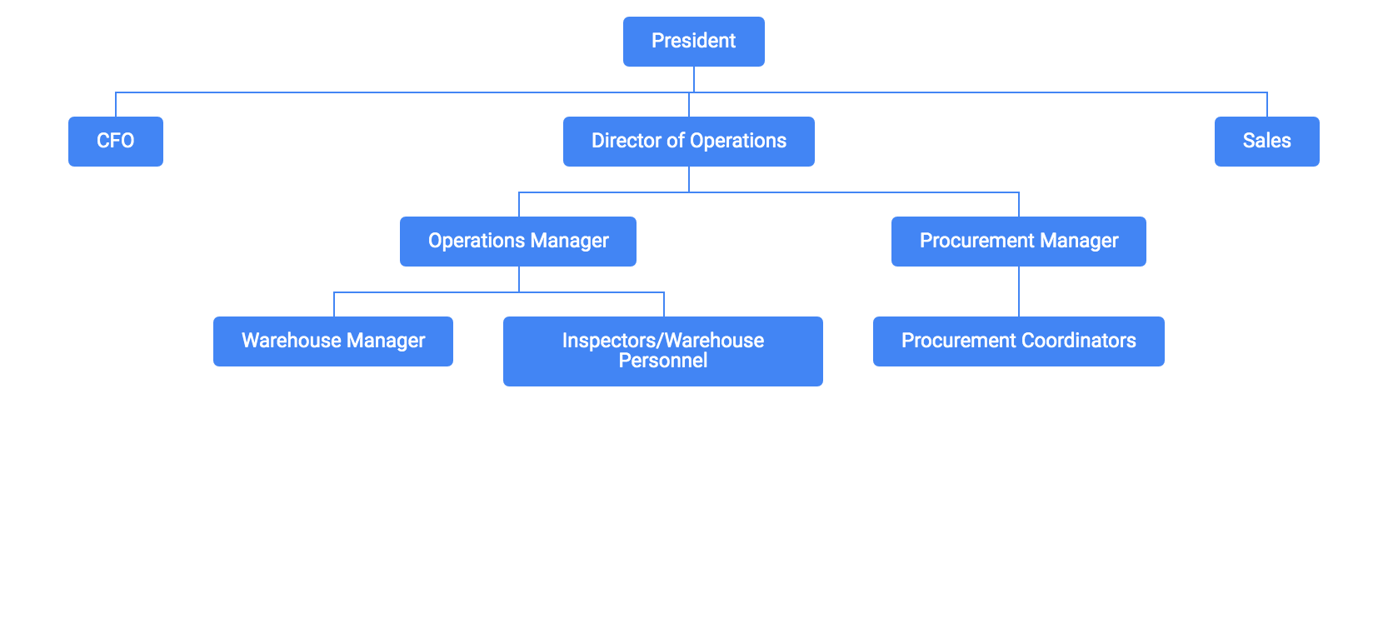

Section: 1

**E.2)** **Personnel Responsibilities**

President: The President is ultimately responsible to assure that the integrity of the quality system is maintained. Such responsibility for routine functions is delegated to staff members as may be described in this manual. In the absence of the President, the Director of Operations shall assume duties performed by the President.

Director of Operations: The Director of Operations reports to the President, and is responsible to accomplish delegated tasks as required. The Director of Operations is also responsible to assure that sales, purchasing, and warehouse employees follow company policy.

Operations Manager: The Operations Manager reports to the Director of Operations and is responsible for the following functions:

* Maintenance of the QAM, QAM distribution list, and inspection roster
* Training of personnel
* Self-audit program
* Assuring any publications referred to in this manual are kept current
* Maintenance of the approved supplier list and quality history
* Records
* Corrective Action Process

In the absence of the Operations Manager, the Director of Operations (and/or Warehouse Manager) shall carry out the duties of the Operations Manager.

Warehouse Manager: The Warehouse Manager reports to the Operations Manager and is responsible for the following functions:

* Training of personnel
* The receiving and shipping inspection functions
* Assuring shelf life and limited life products are properly documented and stored
* Material control of parts in storage area
* Scrap Program
* Hazmat

Inspectors: These employees perform shipping and receiving inspections in accordance

with QAMFORM’s 6 and 7, and must be so authorized by the Ops Manager as noted on the

inspection roster.

Sales/Purchasing personnel: See section 5

Section: 1

**E.3)** The distribution and revision control system for quality documentation and other technical data. See Paragraph 1 C, and section 13.

**E.4)** Record keeping: See section 12.

**E.5)** Training requirements and records: See section 4.

**E.6)** Shelf-life material control: See section 9.

**E.7)** Discrepant material control: See section 8.

**E.8)** Receiving Inspection: See section 6.

**E.9)** Tool and test equipment calibration program: See section 7.

**E.10)** The storage facilities and applicable specifications. See section 3.

**E.11)** Parts identification: See section 8.

**E.12)** Environmental Controls: At this time Skylink does not store any material that requires specific storage temperatures. Nonetheless, the warehouse area is heated and/or cooled appropriately for the climates experienced.

**E.13)** Control of inspection stamps: See section 6 D.

**E.14)** Self-audit program: See section 2.

**E.15)** Corrective Action Process: See section 14.

**E.16)** Hazmat Control and Transport: See section 15.

#### Section: 2 - Self-Audit Program

**A.** The purpose of Skylink’s self-audit program is to assure that the adopted [AC 00-56](https://drive.google.com/file/d/1yv-7gyk_wUsSzGJhpYBhtqUdL52Rwjx2/view?usp=sharing) and [ASA-100](https://drive.google.com/file/d/1s9SCtDTmvaEqF9C0nf1VZWpzG4ZsJIZ5/view?usp=sharing) quality system has been implemented, and to provide the necessary feedback for continuous improvement in the operation. The Operations Manager or a qualified and appropriately authorized designee will perform the self-audit. The audit shall be conducted annually using the ASA-100 self-audit checklist available at *www.aviationsuppliers.org*. The audit may be accomplished in sections scheduled throughout the year. However, all elements of the ASA-100 must be covered within the year. When the self-audit identifies a nonconformity, Skylink shall follow the Corrective Action Process described in Section 14 of this quality manual to address the nonconformity. Nonconformities shall be recorded on [QAMFORM3](https://docs.google.com/document/d/1AlEfBrJJ_86ZTN-oNQqe3w4Kh6X-g15ur7kVeQnGA9g/edit?tab=t.0), Corrective Action Report.

**B.** When seeking accreditation to the ASA-100 standard, Skylink shall contact ASA. ASA-100 is subject to both copyright and trademark protection. ASA is the only entity who is authorized to provide a certification statement clarifying compliance to the ASA-100 Standard. In order to participate in the ASA-100 Accreditation program, Skylink is required to sign a contract and ASA shall audit the distributor under a preset audit plan determined by ASA as stated in the contract. Upon notification by ASA of a successful audit, ASA shall provide Skylink with the appropriate documentation needed to participate in FAA AC 00-56 accreditation. Skylink is not considered accredited until it meets the requirements of FAA AC 00-56. A successful audit result does not relieve Skylink from maintaining its quality system.

#### Section: 3 - Facilities

**A.** Skylink’s facility shall be configured to assure that storage does not damage inventory. Storage areas shall have adequate space and appropriate racks so that parts are stored in a manner that will preclude damage. The existing site has approximately 30,000 square feet of storage and office spaces. There is no “off-site” storage facility. See detailed floor plan of the storage facility on the following page.

**B.** The storage area is secured to prevent unauthorized access. The entire facility is secure, and contains smoke detecting systems as well as posted fire extinguishers. Skylink does not engage in aircraft/component maintenance.

**C.** Skylink deals solely with aircraft parts (and parts that could be reasonably assumed to be sold for aircraft use) in its brokering and distribution operation. In the event of a non-aircraft part entering the facility, it would be segregated from aircraft parts.

**D.** Serviceable parts (including new, overhauled, inspected, repaired etc.) shall be segregated from unserviceable parts (including unserviceable, as removed, as is, repairable, etc.) in a manner that will control the issuance of those parts. Such segregation shall include physically storing these parts in designated areas, and indicating their condition in Skylink’s computerized inventory/sales system.

Section: 3

Floor Plan:

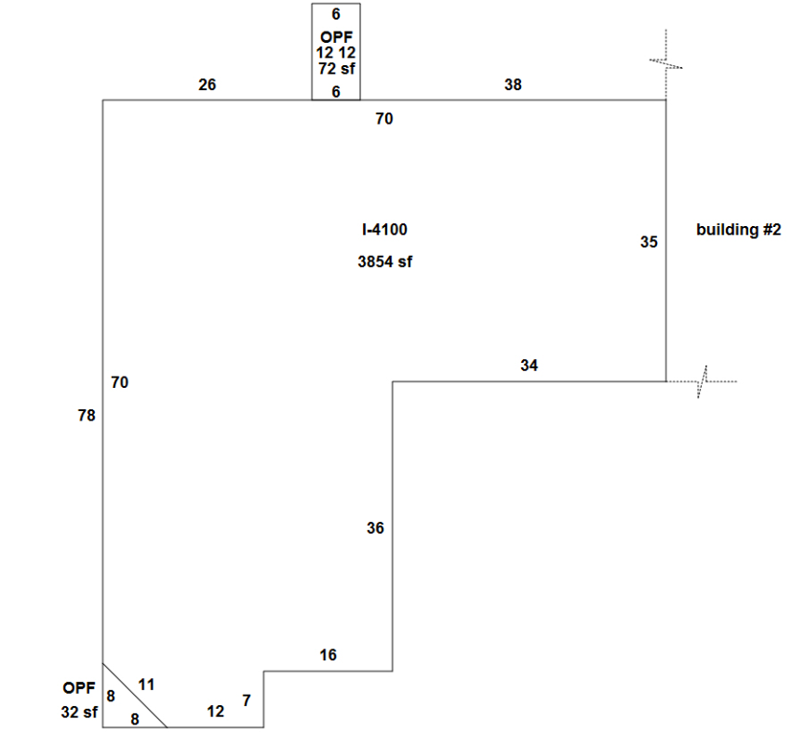

#### Section: 4 - Training and Authorized Personnel

**A.** Skylink shall have personnel who are properly trained to perform inspection, handling and record keeping procedures to support the adopted quality system, which is the ASA-100 and AC 00-56.

**B.** Inspection personnel shall be properly trained and authorized. Skylink personnel authorized to perform receiving inspections, shipping inspections, and to sign Skylink certifications shall be so authorized on [QAMFORM2](https://docs.google.com/document/d/1b44pXRJ7kO8u4U7uDrBOQ7FW72uDYUw9TOTnkEfCdkM/edit?tab=t.0), Inspection Roster. The Ops Manager shall be responsible for maintaining a current roster on file. In order to be placed on this roster, personnel must at a minimum have the following training criteria documented on [QAMFORM4:](https://docs.google.com/document/d/1Sp4DEET_KOXivyH1VMkcNVNcuzEDggDBsJ4tibrJ9C0/edit?tab=t.0)

1. Unapproved parts and counterfeit parts and materials
2. Receiving and shipping inspection
3. ASA-100 familiarization
4. Parts and warehousing
5. Recordkeeping
6. FAA AC 00-56
7. ESD handling
8. Hazmat/DG Awareness
9. All training, both OJT and classroom, shall be documented on [QAMFORM4](https://docs.google.com/document/d/1Sp4DEET_KOXivyH1VMkcNVNcuzEDggDBsJ4tibrJ9C0/edit?tab=t.0), Training Record, or be documented on a certificate of training (or equivalent) in the event the training was performed by organizations external to Skylink. Training records shall be retained for at least two years after the employee has left employment with the company. [QAMFORM4](https://docs.google.com/document/d/1Sp4DEET_KOXivyH1VMkcNVNcuzEDggDBsJ4tibrJ9C0/edit?tab=t.0) includes:
10. Description of the training.
11. Date(s) and length of instruction.
12. Name of the employee receiving training.
13. Signature of the instructor within the organization, or in the case of training received outside the company, the name of the organization providing the training, and the instructor’s name.
14. Any additional information required by law or regulation.

**D.** The roster of personnel authorized to perform inspection functions and their alternates shall be maintained on [QAMFORM2](https://docs.google.com/document/d/1b44pXRJ7kO8u4U7uDrBOQ7FW72uDYUw9TOTnkEfCdkM/edit?tab=t.0) as previously described. Because there are multiple names on the roster, the list itself serves to designate alternates.

Section: 4

**E.** Training program for personnel involved in procurement, receiving inspection, shipping inspection and material control shall include (but not be limited to) identification and recognition of unapproved parts, and counterfeit parts and materials.

#### Section: 5 - Procurement

**A.** Skylink’s procurement system shall assure that materials and components purchased are traceable to a prior source and bear acceptable documentation that conforms to at least one of the receipt requirements listed in appendix A of the ASA-100 Standard. Skylink’s record keeping system described in section 12 of this manual shall serve as the record to demonstrate traceability of such purchased materials and components. This record of traceability shall be supplemented by Skylink’s computerized inventory, sales, and purchasing system. Such information will be provided to interested parties upon request.

1. When a part is drop shipped to Skylink’s customer, all traceability documentation shall be forwarded to Skylink for review and approval prior to the part being shipped to the customer. Skylink shall provide the customer with documentation in accordance with the “Required for Shipment” column of Appendix A of the ASA-100 standard.

**B.** In cases where a customer informs Skylink of any special requirements regarding a part to be purchased, Skylink shall communicate such special requirements to its procurement sources via its purchase order. Deviations of customer’s purchase orders shall be disclosed and approved by the customer.

**C.** All approved suppliers shall be placed on the Skylink’s approved supplier list; basis for approval for each supplier shall be identified. The Ops Manager shall be responsible for the monitoring and control of suppliers on this list.

* PAHs (prime manufacturers, PMA holders, TSO Mfgs) and their authorized distributors, Airlines, Repair Stations/AMOs, FAA AC 00-56 accredited distributors, ISO/AS/EN certified distributors, or AFRA accredited distributors are unrestricted, and not subject to approval via [QAMFORM5,](https://docs.google.com/document/d/1DS_zdiPFcgEEKx-Cmkd2cftDQrpi3miB45Rdt22rs28/edit?tab=t.0) Supplier Audit Form.
* All other suppliers are subject to approval via [QAMFORM5,](https://docs.google.com/document/d/1DS_zdiPFcgEEKx-Cmkd2cftDQrpi3miB45Rdt22rs28/edit?tab=t.0) Supplier Audit Form. The Ops Manager and/or Purchasing Manager shall ensure that no purchases are made unless [QAMFORM5](https://docs.google.com/document/d/1DS_zdiPFcgEEKx-Cmkd2cftDQrpi3miB45Rdt22rs28/edit?tab=t.0) has been sent, and subsequently approved and on file. [QAMFORM5](https://docs.google.com/document/d/1DS_zdiPFcgEEKx-Cmkd2cftDQrpi3miB45Rdt22rs28/edit?tab=t.0) is only issued upon initial setup of the supplier; A supplier’s quality history shall serve as the basis for the sustained approval on [QAMFORM13](https://prod-avs-skylink.lightning.force.com/lightning/r/Report/00OPZ000005sHqb2AE/view?queryScope=userFolders) Approved Suppliers List.
* The process is reflected in the flow chart on the following page.
* A one-time purchase from a supplier that is not on the approved supplier list may be authorized by the Ops Manager based on receipt of acceptable documentation IAW section 5 A of this quality manual.

Section: 5

* [QAMFORM8](https://prod-avs-skylink.lightning.force.com/lightning/r/Report/00OPZ0000064ehl2AA/view?queryScope=userFolders), Receiving/Material Discrepancy Log (a report listing all Vendor QC issue Cases), shall serve to establish the quality history of all suppliers.

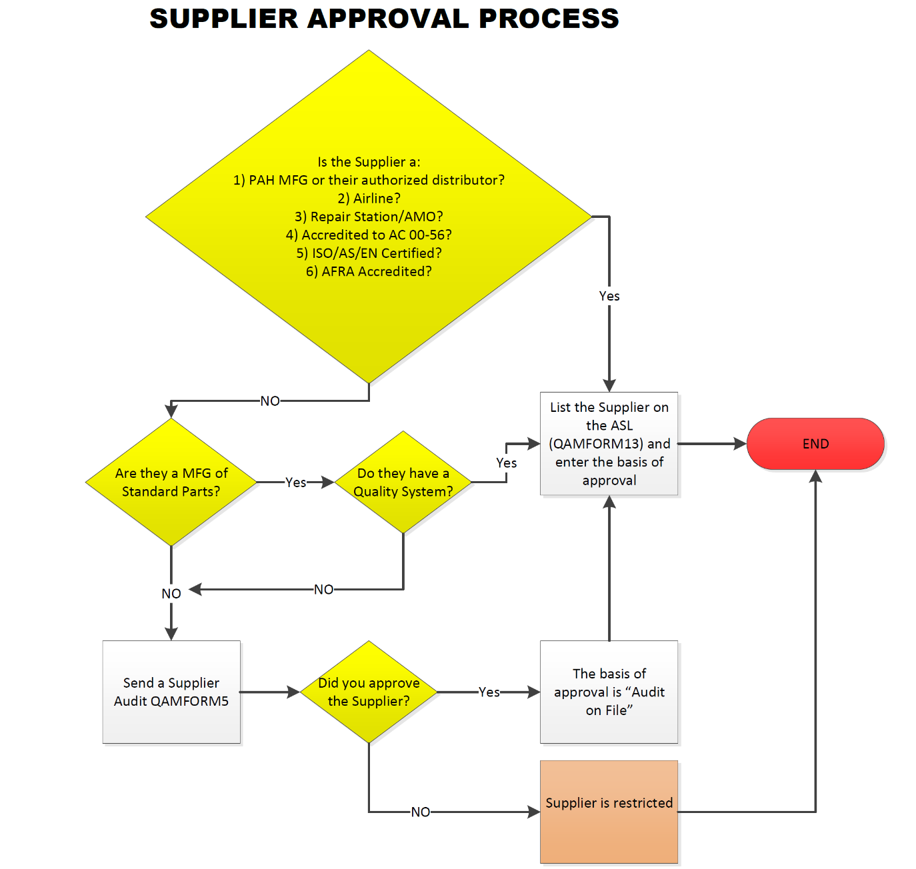

Section: 5

**D.** Skylink shall assure that:

**1)** A part from an aircraft or engine that is known to have been subjected to extreme stress, heat or environment is identified as having been exposed to such circumstances. In addition, parts that are known to have been otherwise subjected to extreme stress or heat (i.e., a warehouse fire) shall also be identified as such to the customer. Skylink’s Purchase Order to its suppliers requires that such parts be identified. When so identified, Skylink will disclose this to the customer upon initial contact, and in the documentation supplied to the customer with the part.

**2)** All Airworthiness Directives (AD’s) that are represented as having been accomplished are documented. Certification of compliance shall specify AD number, AD amendment number, date, and method of compliance, i.e., “AD xx-xx-xx terminated (date). Replaced shaft seal with

P/N _______ shaft seal (signature).” Receiving inspection shall check for such documentation.

**3)** Items identified as overhauled, rebuilt, repaired, inspected, or modified have the appropriate signed (not stamped or preprinted) and dated documentation attached to substantiate the condition of the part. Receiving inspection shall check for the presence of such documentation.

With the exception of activities mentioned in this section to be performed by the Ops Manager or Inspectors, Sales and Purchasing staff are responsible to carry out the requirements herein.

#### Section: 6 - Receiving Inspection

**A**. Inspectors shall conduct a complete visual inspection of all incoming parts and materials, and check for presence of appropriate documentation. Inspections shall be carried out in accordance with [QAMFORM6](https://docs.google.com/document/d/1Qg_8dfO5YAgmDLGFyq-5sI6Q3q51jrQw0JknF6mb7WE/edit?tab=t.0), Receiving Inspection Guide. Documents shall be copied and/or scanned during the receiving inspection process.

**B.** Sample visual inspection of fasteners for workmanship and documentation shall be performed during the receiving process. Certifications provided to Skylink containing information such as physical and chemical properties of fasteners or conformity statements shall be kept on file.

**C.** Suspected Unapproved Parts shall be reported in accordance with [FAA AC 21-29](https://drive.google.com/file/d/1vUDLQvB2e7-_gzKPnPa3ccZ-FyzfSX7Q/view?usp=sharing).

**D.** Inspection stamps shall be used for acceptance and rejection of parts and material. Stamp issuance and control shall be documented on [QAMFORM11](https://docs.google.com/document/d/1PahQidvtevNbbH5saco7As8D6VfNQL2JVlgBfk9-kP4/edit?tab=t.0), Stamp Control Log. Inspection stamp identification imprints shall not be re-used for two years after an inspector to whom the imprint was assigned leaves the position; or the stamp with the imprint is lost or stolen.

**E.** At this time Skylink makes only occasional purchases of standard parts or fasteners; it is not a significant distributor of such commodities. However, sample visual inspection shall be performed when these items are received.  ***At this time Skylink does not purchase raw materials.***

#### Section: 7 - Measuring and Test Equipment

At this time Skylink does not use any measuring and test equipment, either required by contract or for conducting sample inspections.

#### Section: 8 - Material Control

**A.** Material in Skylink’s possession shall be handled in an appropriate manner and shall be protected from damage and deterioration. Special packaging shall be maintained as necessary. A visual check of the storage area shall be performed periodically in conjunction with the self audit to assure the effectiveness of storage and identification methods. Any flammable materials shall be stored in protective cabinets/lockers.

**B.** Batch/Lot control: Segregation of batch and lot shipments for parts so identified by the manufacturer shall be observed. This extends to parts of the same kind and part number received to be stored on the same purchase order. Records of purchases less sales shall equal inventory. Different lot or batch numbered parts shall be stored separately.

**C.** In the event of a recall, Skylink shall use its records and computerized history of sales and purchases to effect a recall and notification of its parts either in inventory, or already shipped to customers.

**D.** Whenever practical, Skylink shall store and deliver parts in the manufacturer’s original packaging. Packaging or attached paperwork shall identify the manufacturer or distributor, the P/N, serial number or batch/lot number, and the quantity. Skylink shall use [ATA Spec 300](https://drive.google.com/file/d/12lisOzo8Vp02Dn7vicpZYhy3LQtEZlPu/view?usp=sharing) packaging or equivalent, or use customer specified packaging when so stated, for example, on the customer’s purchase order. In the event flammable, toxic, or volatile materials are to be shipped, they shall be packaged in a safe manner per manufacturer’s instructions, local regulations, or HAZMAT regulations as applicable.

**E.** ESD protection: Material subject to ESD shall be packaged, handled and protected with necessary precaution, and in accordance with requirements for safe handling. Parts determined to be electrostatic sensitive devices shall not be removed from their protective packaging. If, however, the part must be removed for the purpose of further inspection a grounded ESD mat and wrist strap will be used. Only ESD trained and authorized personnel shall handle this type of product. Reference [ASA ESD Best Practice](https://drive.google.com/file/d/1YN8F4kTyeL5gpznhFpSgSGn4WthZrrBQ/view?usp=sharing).

Section: 8

**F.** Skylink shall assure that serviceable parts or components are adequately protected against the environment and damage by being properly wrapped, packaged, boxed etc., as appropriate. All fluid passages, lines, or electrical connections shall be capped or plugged. When specified by the manufacturer or repair station, parts whose performance would be adversely affected by an ‘unclean’ environment will be protected in accordance with instructions from those sources.

**G.** In order to preclude part number ambiguity, Skylink shall use only the manufacturer’s part number in their storage and labeling of parts. Skylink shall not alter or replace any data plates under any circumstances.

**H.** Material identified as suspect or nonconforming during the receiving inspection, or later, shall be segregated and placed in an area so designated until such suspicion or nonconformance can be properly resolved. All suspect or nonconforming material shall be documented on [QAMFORM8](https://prod-avs-skylink.lightning.force.com/lightning/r/Report/00OPZ0000064ehl2AA/view?queryScope=userFolders) (a report from the computerized system, showing all Receiving discrepancies for Vendor QC issues), Receiving/Material Discrepancy Log as well as the action taken to address the discrepancy. This log shall form the basis of a quality history for affected suppliers; it shall be reviewed on a regular basis and if a trend is observed the Corrective Action Process described in Section 14 shall be initiated.

In the event Skylink discovers that non-conforming material has been shipped to a customer, Skylink shall notify the customer in writing within 24 hours.

**I.** Parts to be scrapped shall be mutilated by drilling, grinding, weld cutting, or other means as necessary to the extent that will preclude the possibility of their being restored and returned to service. Records of such mutilation shall be kept for all serialized and/or life limited parts. Warehouse Manager or Kit Supervisor shall be responsible to verify that the part was adequately mutilated before being discarded. [QAMFORM9](https://prod-avs-skylink.lightning.force.com/lightning/r/Report/00OPZ000005nEOj2AM/view?queryScope=userFolders), Scrapped Parts Log, shall be used to record part number, description, serial number (if applicable), and the date the part was scrapped. [QAMFORM9](https://prod-avs-skylink.lightning.force.com/lightning/r/Report/00OPZ000005nEOj2AM/view?queryScope=userFolders) records shall be maintained for at least 7 years. Subcontractors and/or repair stations utilized by Skylink may perform the scrapping process; however, these businesses shall provide a certificate of destruction for parts scrapped at their facility.

**J.** Skylink shall report suspected unapproved parts to the FAA according to [AC 21-29](https://drive.google.com/file/d/1vUDLQvB2e7-_gzKPnPa3ccZ-FyzfSX7Q/view?usp=sharing) or to the appropriate CAA.

#### Section: 9 - Shelf-Life Control

**A.** Parts which have shelf life limitations, including component subassemblies containing shelf life-limited parts, shall be placed in an area of the warehouse so designated for such parts. Parts placed in this area shall be entered on [QAMFORM10](https://prod-avs-skylink.lightning.force.com/lightning/r/Report/00OPZ000003mdoX2AQ/view?queryScope=userFolders), Shelf Life Items Control Log. The form contains provisions for location, part number, quantity, and expiration date. The form shall be posted in the designated area of storage and checked prior to removing and issuing stock. Parts that have reached the end of their useful shelf life shall be removed from this stock and placed in quarantine for further disposition. No expired material or part will be represented as having remaining shelf life. The Ops Manager is responsible for the administration of the shelf life control program.

The determination of whether a part is shelf life-limited is determined solely by the manufacturer or other certificate holder, such as an airline, or repair station. Skylink shall rely on supplied documentation, part marking, teardown reports, or package marking to determine if shelf life limits exist.

#### Section: 10 - Certification and Release of Materials

**A.** Skylink shall provide the customer with documentation in accordance with the “Required for Shipment” column of Appendix A of the ASA-100 standard. When a Certified True Copy is required for shipment the document shall be stamped with a statement asserting that it is a Certified True Copy of the original.

**B.** The following conditions, when disclosed to Skylink, shall likewise be disclosed to the customer on Skylink’s material certification.

**I)** Parts removed from an aircraft or engine that was subjected to extreme stress, heat or environment such as major engine failure, accident, fire, or saltwater immersion.

**II)** Parts subjected to extreme stress or heat (i.e., warehouse fire).

**III)** Parts previously installed in a public aircraft, such as a government use aircraft or a military aircraft.

**C.** Skylink’s record keeping system described in section 12 of this manual shall serve as the record to demonstrate traceability of purchased materials. This record of traceability shall be supplemented by Skylink’s computerized inventory, sales, and purchasing system.

**D.** The following procedure shall be followed when copies are made for redistribution shipments and when the approval tags are copied:

**I)** A Certified True Copy of the document shall be sent with the shipment. It shall be stamped with a statement asserting that it is a Certified True Copy of the original.

**II)** As parts are issued, quantity in stock shall be decreased in the inventory control system.

**III)** The original document shall remain with the inventory until sold. At which time it shall be kept on file at Skylink for 7 years from the date of sale to the customer.

#### Section: 11 - Shipping

A. Skylink shall use [ATA Spec 300](https://drive.google.com/file/d/12lisOzo8Vp02Dn7vicpZYhy3LQtEZlPu/view?usp=sharing) packaging or equivalent, or as specified by the customer. Parts shall be packed in such a manner as to preclude damage from rough handling of the container.

**B.** Shipping inspections shall be carried out in accordance with [QAMFORM7](https://docs.google.com/document/d/1hLTgsh8yH_UvDAXWmIi5JB76ghWVMFD9HFvcZbM81IE/edit?tab=t.0), Shipping Inspection Guide.

**C.** When Skylink causes an article to be shipped as a drop shipment, Skylink shall review and approve the documentation relating to each article in the drop shipment. [QAMFORM12](https://docs.google.com/document/d/1su-hgIPmXwe1-jOb7wzbbEvjf775kVpOIYNWiXUl19s/edit?tab=t.0) shall be used for this purpose.

#### Section: 12 - Records

**A.** Skylink’s records consist of three areas of storage:

**I)** Records of purchases and sales as kept on its computerized inventory, purchases and sales system.

**II)** Hard copies of applicable documents such as airworthiness tags, material certifications, certificates of conformity, etc. This shall include those documents that contain information such as serial number and lot or batch numbers when applicable. See section 6A.

**III)** Scanned copies of applicable documents such as airworthiness tags, material certs, certificates of conformity etc. This shall include those documents that contain information such as serial number and lot or batch numbers when applicable. See section 6A.

Through the combination of these records, Skylink maintains a system such that data is readily available and identifiable for each customer, and each purchase. Such records shall be maintained for at least 7 years from the date of sale to the customer.

**B.** At this time Skylink makes only occasional purchases of standard parts or fasteners; it is not a significant distributor of such commodities. When however, certifications are provided to Skylink containing information such as physical and chemical properties of fasteners, or conformity statements, copies shall also be kept on file for at least 7 years from the date of sale to the customer. ***At this time Skylink does not purchase raw materials.***

**C.** See paragraph 12 B.

**D.** Copies of records, traceable to a FAA-certificated source or other acceptable source (in accordance with AC 00-56 para. 4(h)), confirming current life-limited status shall be kept on file when applicable.

**E.** Records are stored in an area of the operation protected against damage, alteration, deterioration, or loss. Computer records are backed up periodically.

#### Section: 13 - Technical Data Control

Skylink does not maintain any technical data such as manufacturer’s illustrated parts catalogs, or overhaul manuals. Outdated or any technical data that may be held on-site that is not on revision service shall be conspicuously marked “For Reference Only”.

#### Section: 14 - Corrective Action Process

1. The corrective action process is a closed loop system that identifies the issue (nonconformity/discrepancy) and its cause; implements immediate containment and system correction; and proactively looks forward to make sure a similar issue doesn’t occur.

The Corrective Action Process shall be conducted at minimum in the following cases:

* Identification of suspect or nonconforming material (when a trend is observed)
* Identification of a nonconformity during an internal audit
* Identification of an RMA from a customer due to a quality issue

1. Skylink’s Corrective Action Process shall:
2. Implement a corrective action to correct the immediate (short term) discrepancy when such correction is identified as necessary. The immediate corrective action shall be documented on [QAMFORM3.](https://docs.google.com/document/d/1AlEfBrJJ_86ZTN-oNQqe3w4Kh6X-g15ur7kVeQnGA9g/edit?tab=t.0)
3. Ensure that the containment action when applicable is appropriate to limit the problem identified. The method of containment shall be documented on [QAMFORM3](https://docs.google.com/document/d/1AlEfBrJJ_86ZTN-oNQqe3w4Kh6X-g15ur7kVeQnGA9g/edit?tab=t.0).
4. Identify the root cause of the discrepancy using root cause analysis and implement corrective action if required. The corrective action if required, root cause and the method used to establish the root cause shall be identified on [QAMFORM3](https://docs.google.com/document/d/1AlEfBrJJ_86ZTN-oNQqe3w4Kh6X-g15ur7kVeQnGA9g/edit?tab=t.0).
5. Implement necessary actions, which may include a corrective action plan, that are appropriate for the problem identified. Immediate correction and containment actions if required shall be implemented as soon as reasonably possible, all other responses shall be obtained in a timely manner.
6. Locate and correct similar discrepancies, if they exist, by inspecting other areas that could be affected by the same discrepancy. Similar discrepancies shall be documented on [QAMFORM3](https://docs.google.com/document/d/1AlEfBrJJ_86ZTN-oNQqe3w4Kh6X-g15ur7kVeQnGA9g/edit?tab=t.0).
7. Implement follow-up action(s) to prevent recurrence of the discrepancy. The organization shall look for objective evidence that the corrective action implemented effectively eliminated the root cause. Follow-up action(s) shall be documented on [QAMFORM3](https://docs.google.com/document/d/1AlEfBrJJ_86ZTN-oNQqe3w4Kh6X-g15ur7kVeQnGA9g/edit?tab=t.0). Follow-up action(s) shall be taken in a timely manner.
8. [QAMFORM3](https://docs.google.com/document/d/1AlEfBrJJ_86ZTN-oNQqe3w4Kh6X-g15ur7kVeQnGA9g/edit?tab=t.0) shall be used to document the Corrective Action Process. All fields shall be completed, and in cases where the entry is not applicable, “N/A” shall be entered. Ops Manager shall be responsible for the Corrective Action Process.

#### Section: 15 - Hazmat Control and Transport

1. Skylinkshall follow [Title 49 of the Code of Federal Regulations (49 CFR)](https://www.ecfr.gov/current/title-49). Skylink’s training program for personnel involved with hazardous material (hazmat) shall include hazardous material awareness, control of hazardous material and shipping process for hazardous material.

#### Section: ASA-100 Appendix A

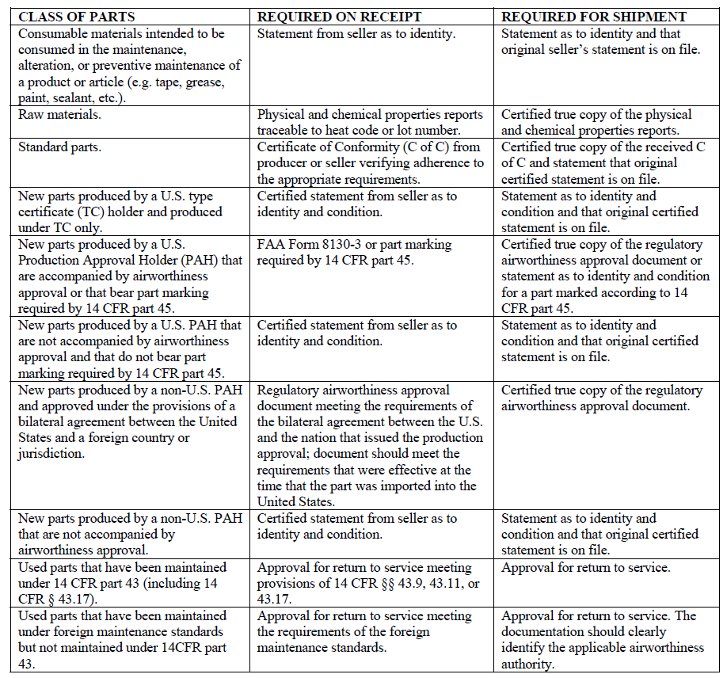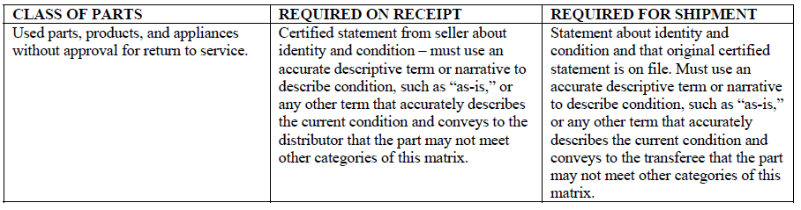

**Quality Assurance Manual Distribution List**

#### QAMFORM1

[**Linked Here**](https://docs.google.com/document/d/1fWqZpHmToYce2R-irzxWQuTRaH8xVFr8eaiosRs4cjM/edit?tab=t.0) **for Live file/document**

| **Manual #** | **Issued To:** |
| --- | --- |
|  |  |
|  |  |
|  |  |

**Inspection Roster**

#### QAMFORM2

[**Linked Here**](https://docs.google.com/document/d/1b44pXRJ7kO8u4U7uDrBOQ7FW72uDYUw9TOTnkEfCdkM/edit?tab=t.0) **to Live file/document**

Roster Updated on: 11/7/2024

| **Name** | **Receiving Inspection** | **Shipping Inspection** | **Material Certifications** | **Hazmat** | **ESD** |
| --- | --- | --- | --- | --- | --- |
|  |  |  |  |  |  |
|  |  |  |  |  |  |
|  |  |  |  |  |  |
|  |  |  |  |  |  |
|  |  |  |  |  |  |

**Cases (Corrective Action Report)**

#### QAMFORM3

[Link here](https://docs.google.com/document/d/1AlEfBrJJ_86ZTN-oNQqe3w4Kh6X-g15ur7kVeQnGA9g/edit?tab=t.0) to Google Doc // [Link here](https://prod-avs-skylink.lightning.force.com/lightning/o/Case/list?filterName=__Recent) to live Cases page in AvSight

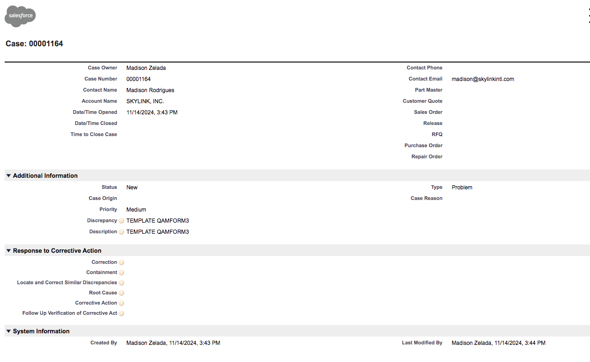

**Training Record**

#### QAMFORM4

[**Linked Here**](https://docs.google.com/document/d/1Sp4DEET_KOXivyH1VMkcNVNcuzEDggDBsJ4tibrJ9C0/edit?tab=t.0) **for Live file/document**

Name of Employee: __________________________

| **Description** | **Date** | **Duration** | **Instructor Signature/Organization & Instructor Name** | **OJT** | **Classroom** |
| --- | --- | --- | --- | --- | --- |
|  |  |  |  |  |  |
|  |  |  |  |  |  |
|  |  |  |  |  |  |
|  |  |  |  |  |  |
|  |  |  |  |  |  |

**Supplier Audit Form**

#### QAMFORM 5

[**Linked Here**](https://docs.google.com/document/d/1DS_zdiPFcgEEKx-Cmkd2cftDQrpi3miB45Rdt22rs28/edit?tab=t.0) **for Live file/document**

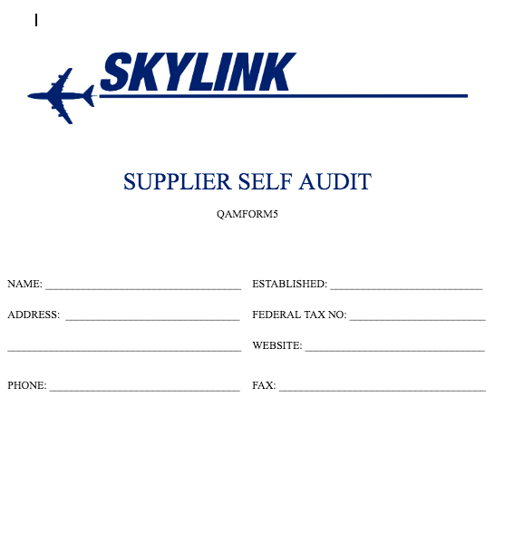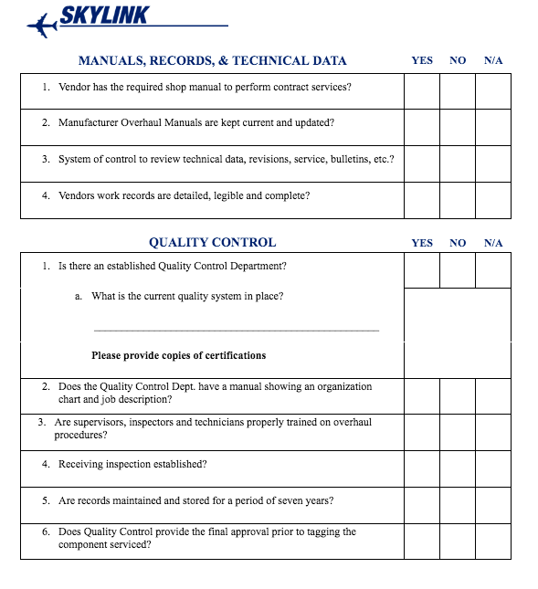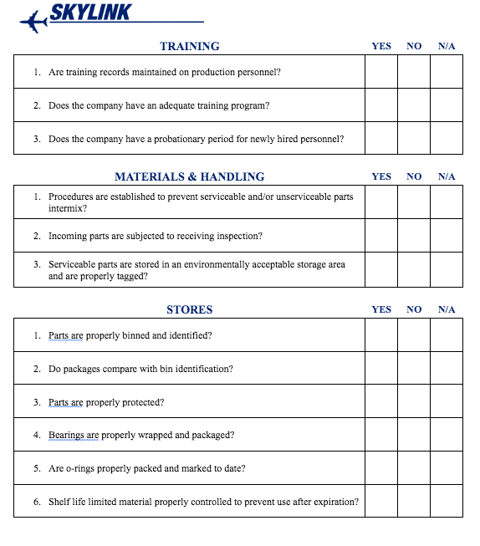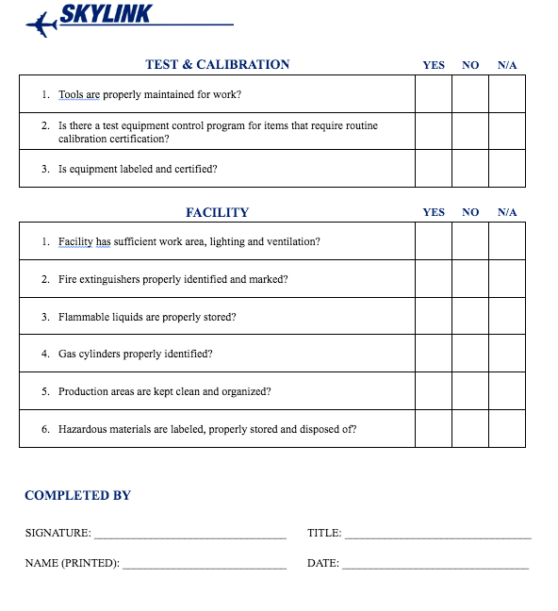

**Receiving Inspection Guide**

#### QAMFORM6

[Linked Here](https://docs.google.com/document/d/10Iofxx_jT2lzVlIgatZSFlE42-aSlWaEPif-vFi4YsM/edit?tab=t.0#heading=h.2mskdbxl44i) & [Here](https://docs.google.com/document/d/1Qg_8dfO5YAgmDLGFyq-5sI6Q3q51jrQw0JknF6mb7WE/edit?tab=t.0) for Live File/Document

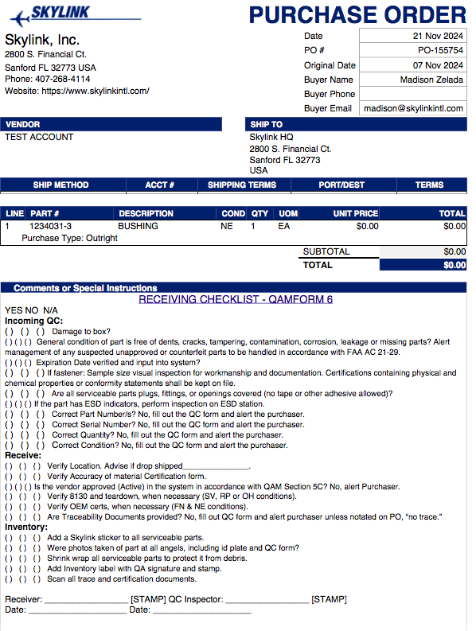

**Shipping Inspection Guide**

#### QAMFORM7

[Linked Here](https://docs.google.com/document/d/10Iofxx_jT2lzVlIgatZSFlE42-aSlWaEPif-vFi4YsM/edit?tab=t.0) & [Here](https://docs.google.com/document/d/1hLTgsh8yH_UvDAXWmIi5JB76ghWVMFD9HFvcZbM81IE/edit?tab=t.0) for Live File/Document

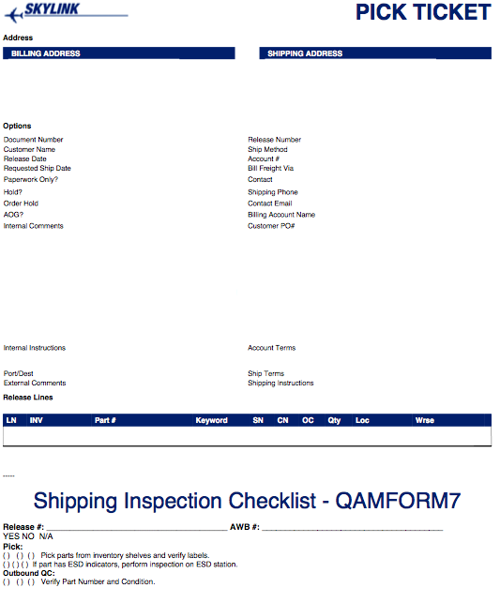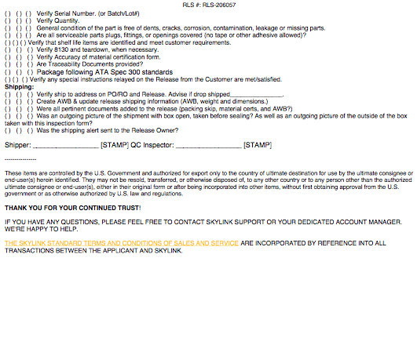

**Receiving/Material Discrepancy Log**

#### QAMFORM8

[Linked Here](https://prod-avs-skylink.lightning.force.com/lightning/r/Report/00OPZ0000064ehl2AA/view?queryScope=userFolders) for Live Report in computerized system

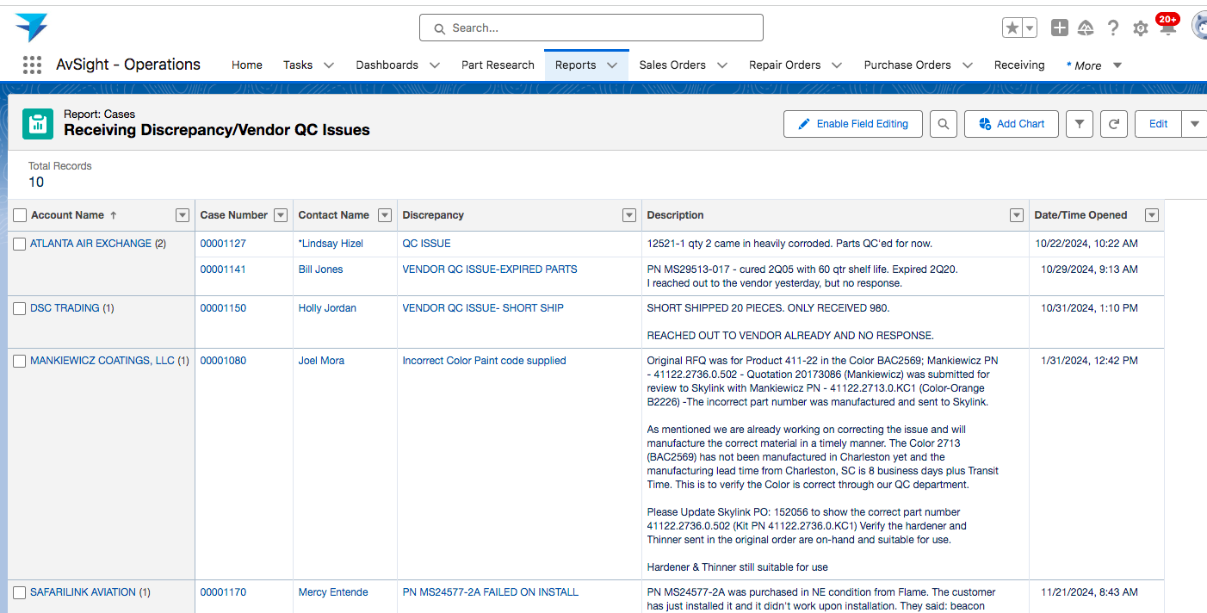

**Scrap Log**

#### QAMFORM9

[Linked Here](https://prod-avs-skylink.lightning.force.com/lightning/r/Report/00OPZ000005nEOj2AM/view?queryScope=userFolders) for Live Report/Log of all scrapped items

[Linked Here](https://drive.google.com/file/d/1o9x_bG29b-IF-nlwTopDa63syTvinb_P/view?usp=sharing) for Live file/document of Scrap Certificate Template

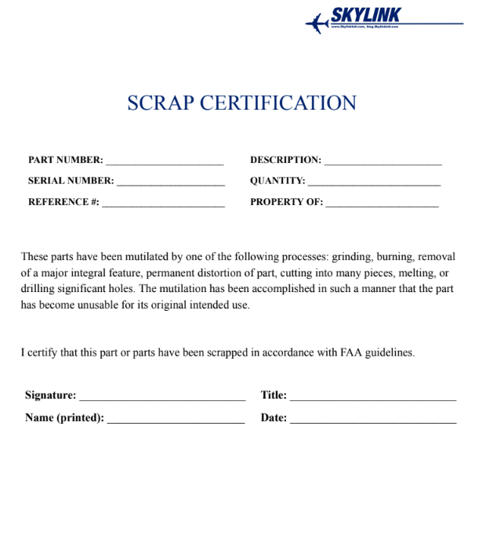

**Shelf Life Control Log**

#### QAMFORM10

[Linked here](https://prod-avs-skylink.lightning.force.com/lightning/r/Report/00OPZ000003mdoX2AQ/view?queryScope=userFolders) for Live log/report - (computerized inventory/history report)

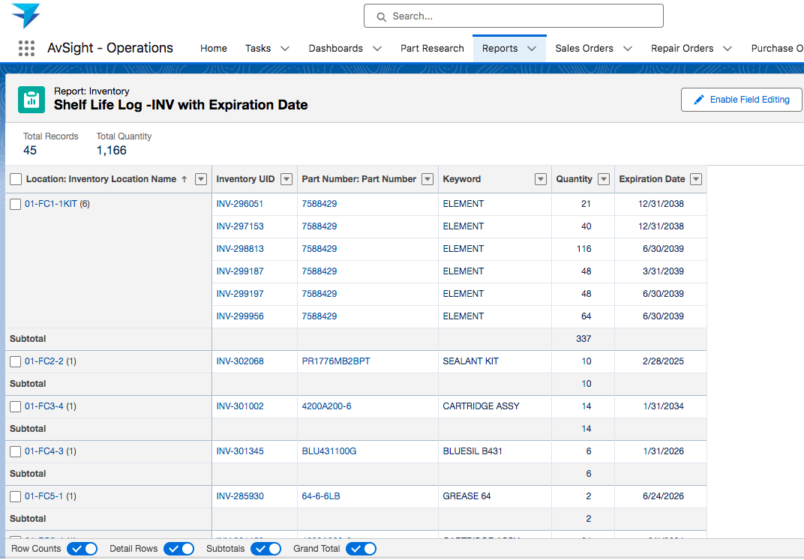

**Stamp Control Log**

#### QAMFORM11

[**Linked Here**](https://docs.google.com/document/d/1PahQidvtevNbbH5saco7As8D6VfNQL2JVlgBfk9-kP4/edit?tab=t.0) **for Live file/document**

| **Stamp #** | **Date Issued** | **Date Retired** | **Inspector Name** | **Imprint** |
| --- | --- | --- | --- | --- |
|  |  |  |  |  |
|  |  |  |  |  |
|  |  |  |  |  |
|  |  |  |  |  |
|  |  |  |  |  |

**Drop Ship Checklist**

#### QAMFORM12

[Linked Here](https://docs.google.com/document/d/1su-hgIPmXwe1-jOb7wzbbEvjf775kVpOIYNWiXUl19s/edit?tab=t.0) for Live file/document

*{{When a part is to be shipped from a supplier directly to the customer (bypassing our receiving and shipping process), this Checklist shall be completed by the person approving the transaction. Make a copy of above linked template.}}*

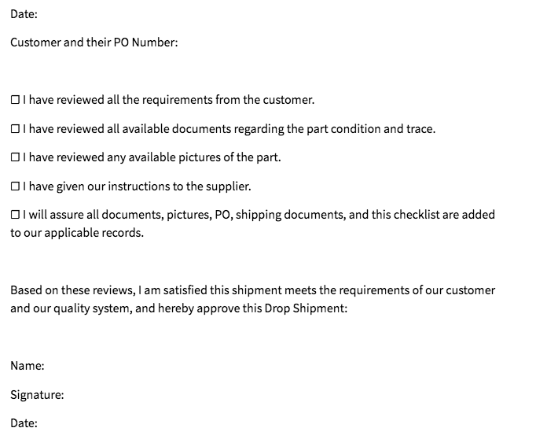

**Approved Suppliers List**

#### QAMFORM13

[Linked here](https://prod-avs-skylink.lightning.force.com/lightning/r/Report/00OPZ000005sHqb2AE/view?queryScope=userFolders) for Live Report/list in our computerized system

